**Practical No 01**

Name : Sakshi Ganesh Koli

Roll No : 13243

Batch : B2

Database Management System Laboratory

**Problem Statement :** Propose a Conceptual Design using ER features using tools like ERD plus, ER Win etc. (Identifying entities, relationships between entities, attributes, keys, cardinalities, generalization, specialization etc.) Convert the ER diagram into relational tables and normalize Relational data model.

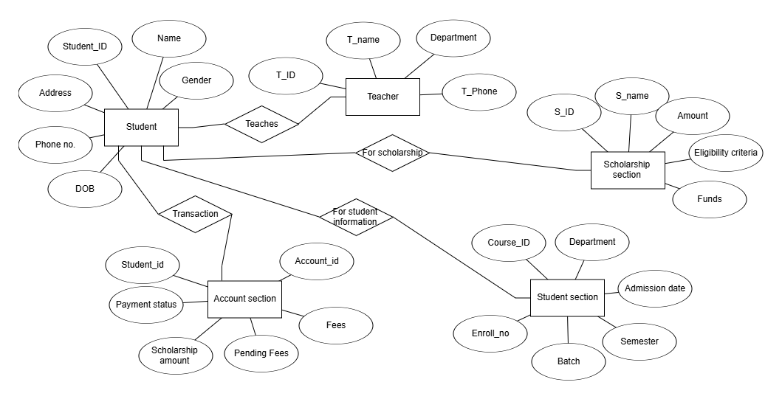

Student management System